SKILL 11 : USE ADJECTIVE CLAUSE CONNECTORS CORRECTLY

Adjective clause adalah sebuah clause yang mendeskripsikan sebuah noun. Dikarenakan dia adalah sebuah clausa maka posisinya tepat setelah noun yang di deskripsikan. Contoh :
- The woman is filling the glass that she put on the table.
- The glass that she put on the table contains milk.
- I liked the book which you recommended
- The book which you recommended was interesting
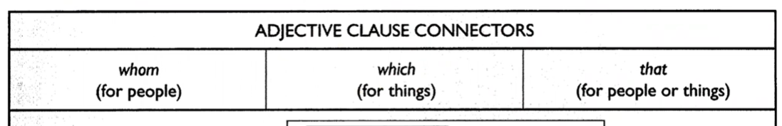

Latihan
Choose correct or incorrect for the following sentences
- It is important to fill out the form in the way that you have been instructed
- Correct
- Incorrect
- The car which I have been driving for five years for sale at a really good price
- Correct
- Incorrect
- I just finished reading the novel whom the professor suggested for my book report
- Correct
- Incorrect
- The plane that he was scheduled to take to Hawaii was delayed
- Correct
- Incorrect
- The movie which we watched on cable last night it was really frightening
- Correct
- Incorrect

SKILL 12 : USE ADJECTIVE CLAUSE CONNETORS/SUBJCET CORRECTLY

Di skill 11 kita tahu bahwa connector pada adjective clause digunakan untuk membuat clause yang berbentuk noun. Di skill 12 kita akan melihat bahwa dalam beberapa kasus, connector dari adjective clause tidak berfungsi hanya sebagai connector saja tetapi bisa menjadi subject dari clause tersebut. Contoh:
- The woman is filling the glass that is on the table
- The glass that is on the table contains milk
- She needs a secretary who types fast
- A secretary who types fast is invaluable
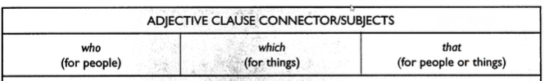

Latihan
Choose correct or incorrect for the following sentences
- The ice cream that is served in the restaurant has a smooth, creamy texture
- Correct
- Incorrect
- The cars are trying to enter the freeway system are lined up for blocks
- Correct
- Incorrect
- I have a great respect for everyone who on the Dean’s List
- Correct
- Incorrect
- It is going to be very difficult to work with the man which just began working here
- Correct
- Incorrect
- The door that leads to the fault it was tightly locked
- Correct
- Incorrect

EVALUASI SKILL 11 DAN SKILL 12

- Choose correct or incorrect for the following sentences
- I made an appointment with the doctor whom you recommended
- Correct
- Incorrect
- The enthusiasm with which he greeted me made me feel welcome.
- Correct
- Incorrect
- The story that you told me about Bob
- Correct
- Incorrect
- The men with whom were having the discussion did not seem very friendly
- Correct
- Incorrect
- I’m not really sure about taking part in the plans that we made last night
- Correct
- Incorrect
- The neighbors reported the man who was trying to break into the car to the police
- Correct
- Incorrect
- These plants can only survive in an environment is extremely humid
- Correct
- Incorrect
- The boss meets with any production workers who they have surpassed their quotas
- Correct
- Incorrect
- The salesclerk ran after the woman who had left her credit card in the store
- Correct
- Incorrect
- The shoes which matched the dress that was on sale
- Correct
- Incorrect
- Choose A, B, C, or D for the incorrect structure at the following sentences
- The artist who(A) the critics praised(B) recently(C) released(D) a new album.
- Who
- the critics praised
- recently
- released
- The movie which(A) we watched(B) last night(C) very interesting(D).
- Which
- we watched
- last night
- very interesting
- The ideas who(A) were presented during(B) the meeting were(C) quite innovative(D).
- Who
- During
- the meeting were
- innovative
- The artist drew(A) the portrait is(B) known for(C) her realistic style(D).
- The artist drew
- Is
- known for
- style
- We need to contact the person which(A) handles(B) customer complaints(C) regarding this issue(D).
- the person which
- handles
- customer complaints
- issue
- The report which(A) the team they(B) prepared lacked(C) sufficient data(D).
- Which
- the team they
- prepared lacked
- data

- The student whom(A) answered(B) the professor's question correctly(C) received extra credit(D).
- Whom
- Answered
- the professor's question correctly
- received extra credit
- The car which(A) it hit(B) the fence(C) belongs(D) to my neighbor.
- Which
- it hit
- the fence
- belongs
- The candidates who(A) attends(B) the interview(C) must be qualified(D).
- Who
- Attends
- the interview
- qualified
- That all police officers(A) have(B) at least four hours of hazardous materials response training(C) is mandating(D) by federal law.
- That all police officers
- Have
- Training
- is mandating

- Choose A, B, C or D for the correct answer at the following sentences
- I enjoyed the book .
- that recommended you
- you recommended it
- which you recommended
- whose recommendation
- The house which stands on the hill _______ magnificent views.
- it has
- has
- having
- that it has
- The professor _______ gave an interesting lecture.
- whom the students admired
- who admired the students
- the students admired him
- admired the students
- The report _______ discusses the recent findings is comprehensive.
- that it
- which
- that discusses
- is discusses
- Scientists are now beginning to conduct experiments on ______ trigger different sorts of health risks.
- Noise pollution can
- That noise pollution
- How noise pollution
- How noise pollution can

